**Part I:**

Load ptr to first value in FAHTEMP

Load ptr to first value in FAHAVG

Load register with counter value

Repeat

Load register with first FAHTEMP value, decrement by 1

Add FAHTEMP value to holding register

Decrement counter

Until counter = 0

Divide holding register by 16

Add carry if any to the holding register

Store the holder register

**Part II – Attempt II:**

Pass in pointer to data and length using R0, R1

Save register to be used in program on the stack

Copy data ptr to secondary register (2)

Copy counter to secondary register (2)

Load first value from data ptr(1) into register, increment data pointer by 1

Subtract counter(1) by 1

Repeat

Load next value from data ptr into second register, increment by 1

Compare values

Store the largest value back in first register

Decrement counter 1

Until counter = 0

Load first value from data ptr(2) into register, increment data pointer by 1

Subtract counter(2) by 1

Repeat

Load next value from data ptr into second register, increment by 1

Compare values

Store the smallest value back in first register

Decrement counter 1

Until counter = 0

Restore Stack

Carry min max values out using R2 and R3

**Part II – Attempt III:**

Pass in pointer to data and length using R0, R1

Save register to be used in program on the stack

Load first value from data ptr into register, increment data pointer by 1

Copy first value from data ptr into secondary register

Subtract counter by 1

Repeat

Load next value from data ptr into second register, increment by 1

Compare values

Store the largest value back in first register

Compare values

Store the smallest value back in the second register

Decrement counter 1

Until counter = 0

Restore Stack

Carry min max values out using R2 and R3

# Breakdown of compare

R4 is always holding values from the data array, R2 holds the largest to be seen:

CMP R2, R4

MOVMI R2, R4

If R2 > R4, then Z = 0, N = 0, MOVMI DOES NOT trigger, R2 is saved

If R2 < R4, then Z = 0, N = 1, MOVMI triggers, R4 is saved over R2

If R2 = R4, then it doesn’t matter if MOVMI occurs or not

This works the exact same way to save the smallest value, but PL is used instead which is the opposite of MI, so it saves all smaller values.

# Stack Breakdown

Before push

After Push

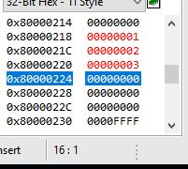

Here I tested the stack using the values 0x03, 0x02, 0x01.

R4 = 0x03

R1 = 0x02

R0 = 0x01

|  |  |  |  |
| --- | --- | --- | --- |
| Before Push | 0x224 | 0000000000 |  |
|  | 0x220 | 0x03 | R4 |
|  | 0x20c | 0x02 | R1 |
| After Push | 0x218 | 0x01 | R2 |
|  | 0x214 | 0000000000 |  |

Stack started at 0x124, added 0x100, since I’m using FD, the first spot 0x224 is empty, and the stack ends up pointing to 0x218.

# Output Value Breakdown

Max

Avg

Min

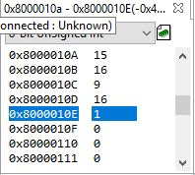

|  |  |  |
| --- | --- | --- |
| Test Values | 1, 2, 3, 4, 5, 6, 7, 8, 9, 10, 11, 12, 13, 14, 15, 16 | |
|  | Expected Result | Program Output |
| Average | 8.5 | 9 |
| MAX | 16 | 16 |
| MIN | 1 | 1 |

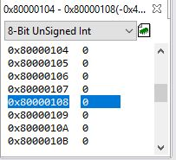

|  |  |  |
| --- | --- | --- |
| Test Values | 0, 0, 0, 0, 0, 0, 0, 0, 0, 0, 0, 0, 0, 0, 0, 0 | |
|  | Expected Result | Program Output |
| Average | 0 | 0 |
| MAX | 0 | 0 |
| MIN | 0 | 0 |

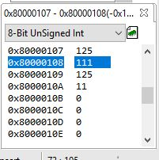

|  |  |  |
| --- | --- | --- |
| Test Values | 125, 125, 125, 125, 125, 12, 125, 125, 125, 125, 125, 125, 11, 125, 125, 125 | |
|  | Expected Result | Program Output |
| Average | 110.8 | 111 |
| MAX | 125 | 125 |
| MIN | 11 | 11 |

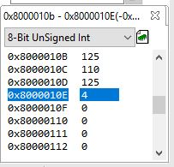

|  |  |  |
| --- | --- | --- |
| Test Values | 125, 125, 125, 125, 125, 11, 125, 125, 125, 125, 125, 125, 4, 125, 125, 125 | |
|  | Expected Result | Program Output |
| Average | 110.31 | 110 |
| MAX | 125 | 125 |
| MIN | 4 | 4 |